You need to make sure that you can do the following: Can you do it?

- Importing a .CSV file in to MS Access database

First CREATE the Database in the work folder. Then IMPORT the file.

Set DATA TYPES as you are importing the file.

Set the PRIMARY KEY during import. If there is no indication in the question paper about a unique number then choose the DEFAULT that Access database sets.
If there is information such as “The VIN is the Vehicle Identification
Number, and each car will have a different VIN.” Then choose this field as the primary key!!!

After you import the file than the table is opened in DATASHEET VIEW. You then need to
View the table in DESIGN VIEW.

Check through the data types from the question paper and do the remaining FORMATTING such as:

- Setting decimal places
- Setting BOOLEAN field to Yes/No
- Formatting DATE field

- Showing screen shots of FIELD NAMES and DATA TYPES

Make sure your screen shots show any FORMATTING such as set DECIMAL PLACES , BOOLEAN settings and DATE FORMAT.

You may need to show it in several screen shots!

- Inserting NEW RECORDS

Use DATA SHEET VIEW to enter the new records.
Be careful with spelling! Enter as shown in the question paper!

Can you do it?
- Producing REPORTs
ALWAYS CREATE A QUERY FIRST!!!
Read the bullet points one by one and DO THE ONES THAT NEEDS TO BE DONE IN THE QUERY FIRST.
Everything else such as PAGE ORIENTATION, ENTERING A TITLE etc That can be done when creating the REPORT!
SELECT ALL THE FIELDS in your QUERY, BUT only choose the FIELDS that you need to show in the report WHEN CREATING THE REPORT through the REPORT WIZARD! (You may need some of the fields for calculations even though you may asked not to show them in the report!)
SORTING can be done in the query.
Ascending: Smaller to larger
Descending: Larger to smaller
If you are asked to include A NEW FIELD THAT IS CALCULATED IN RUN TIME, then insert that field in the QUERY.
e.g. As shown below:
REMEMBER field names are in [] square brackets!
This is the new field name that is not in the table!!! (PROFIT and PERCENT).
Can you do it?
CALCULATIONS such as MAX, MIN, SUM, COUNT can be done in the REPORT FOOTER section of the REPORT.

Use LABEL icon to type in your candidate name, number and centre number in the PAGE FOOTER section of the REPORT DESIGN VIEW!

- Showing only the asked records
USE ASEARCH CRITERIA to find and display the records wanted in the question paper!

REMEMBER < is LESS THAN
>is GRATER THAN
6. Formatting a calculated field to CURRENCY in the report
IN THE DESIGN VIEW, select the DATA FIELD and set to currency and to decimal places in the PROPERTIES window.
Can you do it?

- Calculating SUM, MAX, MIN, AVERAGE and number of items

- Making sure that all FIELD NAMES (LABELS) and VALUES (DATA) are FULLY VISIBLE

Adjust the COLUMN WIDTHS in DATA SHEET VIEW buy dragging the columns narrower or wider.

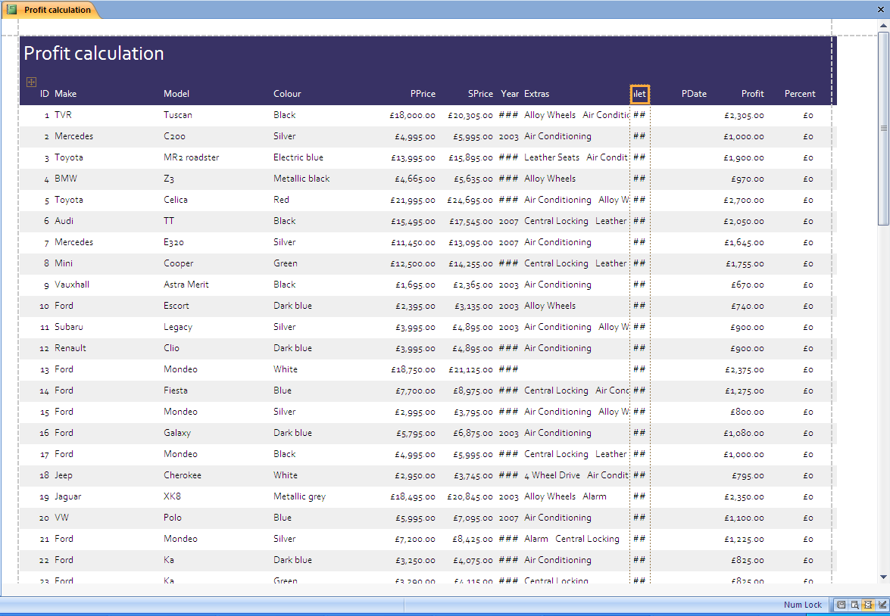

Can you do it?
- Exporting the report as a WEB PAGE (or to Word or Excel)

- Producing labels from all the data which:

• fit two side by side on the page
• show only specific records
• show only the fields Make, Model, Size, Price and Wind condition, each on a separate line
• display the field name as well as the data
• are sorted into ascending order of a field
• include the heading at the top of each label
• have your name, Centre number and candidate number at the bottom of each label.

Do the following steps:

FIRST select the TABLE / QUERY OR REPORT that you want to base the labels on.

Leave the default (don’t change anything) CLICK NEXT.

Don’t change anything unless you are asked to do so. Click Next.

Select only the fields that you are asked to show. Click NEXT.

Make sure that you press ENTER/RETURN key on the keyboard IF YOU ARE ASKED TO ENTER EACH FIELD IN A NEW LINE!

Adding the field such as {Make} WILL ONLY PRINT THE ACTUAL DATA. IF YOU WANT TO DISPLAY THE LABEL such as “Make:” with it then you need to first type”Make:” and then seleck the field {Make}!!!

Select the field that you want to SORT on. Click NEXT.

Click FINISH.

It will look like this:

Then you can do further FORMATTING like inserting a title or your name, candidate no and centre number in DESIGN VIEW using LABEL icon.

Can you do it?

- Producing and EXTRACT from a set of conditions

You need to CREATE A QUERY based on the conditions given and when you run the query a list of values will be displayed.

You can then EXPORT / IMPORT this data to Word or Excel.

- Showing evidence as a screen shot

Make sure that you crop the image so it is readable.

Make sure what you are asked to show evidence of is shown in the screen shot!!!

Resize the image by dragging it from the corners to keep to ASPECT RATIO.

Make sure you enter your name, candidate no and centre number in the header/footer.

- Setting the page orientation to PORTRAIT / LANDSCAPE

- Aligning / Justifying text (e.g. left, right, center and full)

- Setting the font size

- Formatting text (e.g. Underline, embold / bold, italic)

