You need to make sure that you can do the following: Can you do it?

- Creating a master slide with the following styles:

e.g.
  - titles should be in a 36 point serif font and centred
  - subtitles should be in an 18 point serif font and left aligned
  - bullets should be left aligned and consistent

Open MS PowerPoint.
View Slide Master.

Select the first slide.
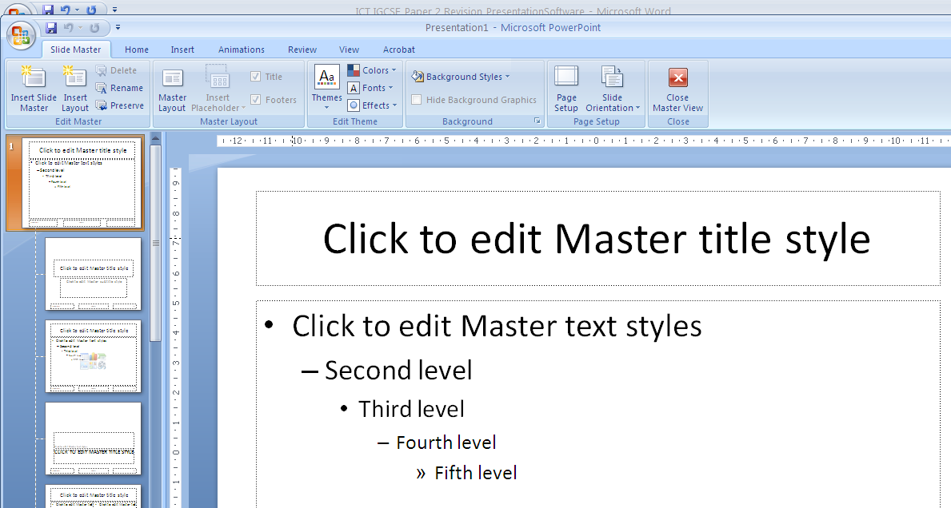Format as requested.
Can you do it?
- Placing the following items on the master slide:

e.g.
  - Draw two thick (about 3 point) vertical lines down the slide on the left side
  - Draw a thick (about 3 point) horizontal line across the width of the slide about 3 cm from the top of the slide
  - Find a picture of a star from clipart and place this between the vertical lines above the horizontal line
  - Enter your name, Centre number and candidate number in a 12 point serif font at the bottom left of the master slide but not overlapping the lines
  - Slide numbers should appear at the bottom right of each slide

To insert lines:

To set thickness of the line:
Vertical Line Horizontal Line

To enter name, candidate no and centre number INSERT FOOTER / HEADER

Click in Footer and APPLY TO ALL.

Then move the text box to the place it is required!

NOTICE THAT the Slide Number box needs to be TICKED in order for it to be displayed in normal view.

CLOSE the Master Slide view when you have finished with formatting.

Click on SLIDE MASTER tab then select CLOSE icon.

That will take you to the NORMAL VIEW.
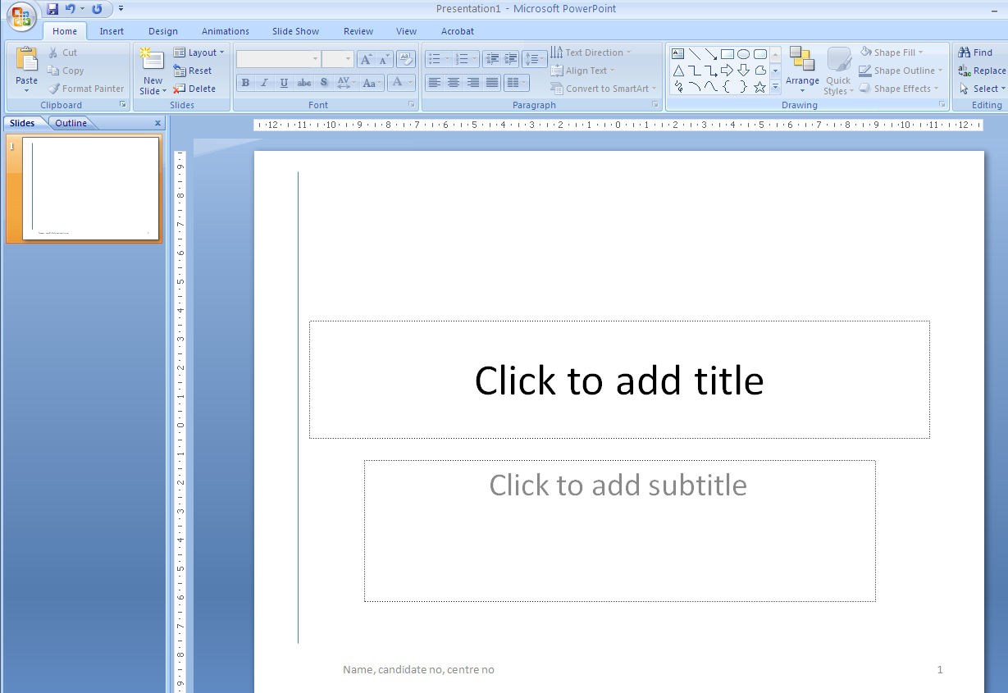
Your details and the page number should be showing, IF NOT then go back to HEADER / FOOTER and tick the boxes.

Can you do it?
- Importing a .RTF file in to the presentation

Open the .RTF file in PowerPoint.

Make sure All Files selected in the Files of Type window!
The content of the file will be inserted as slides into the PowerPoint presentation as shown below.
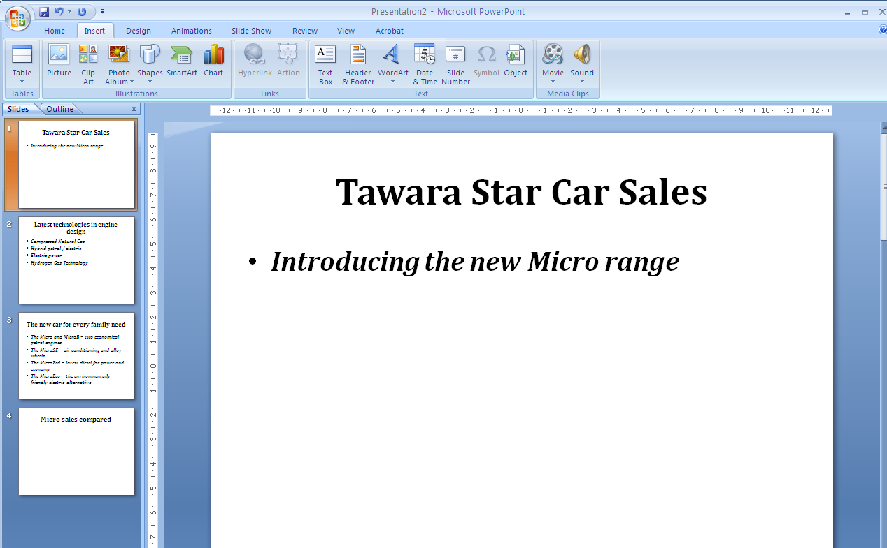
Can you do it?
- Creating a CHART from a .CSV file and inserting into the presentation
Open the .CSV file.
Create the chart.
Copy and paste into the presentation in to the required slide.

- Adding PRESENTATION NOTES to the slide
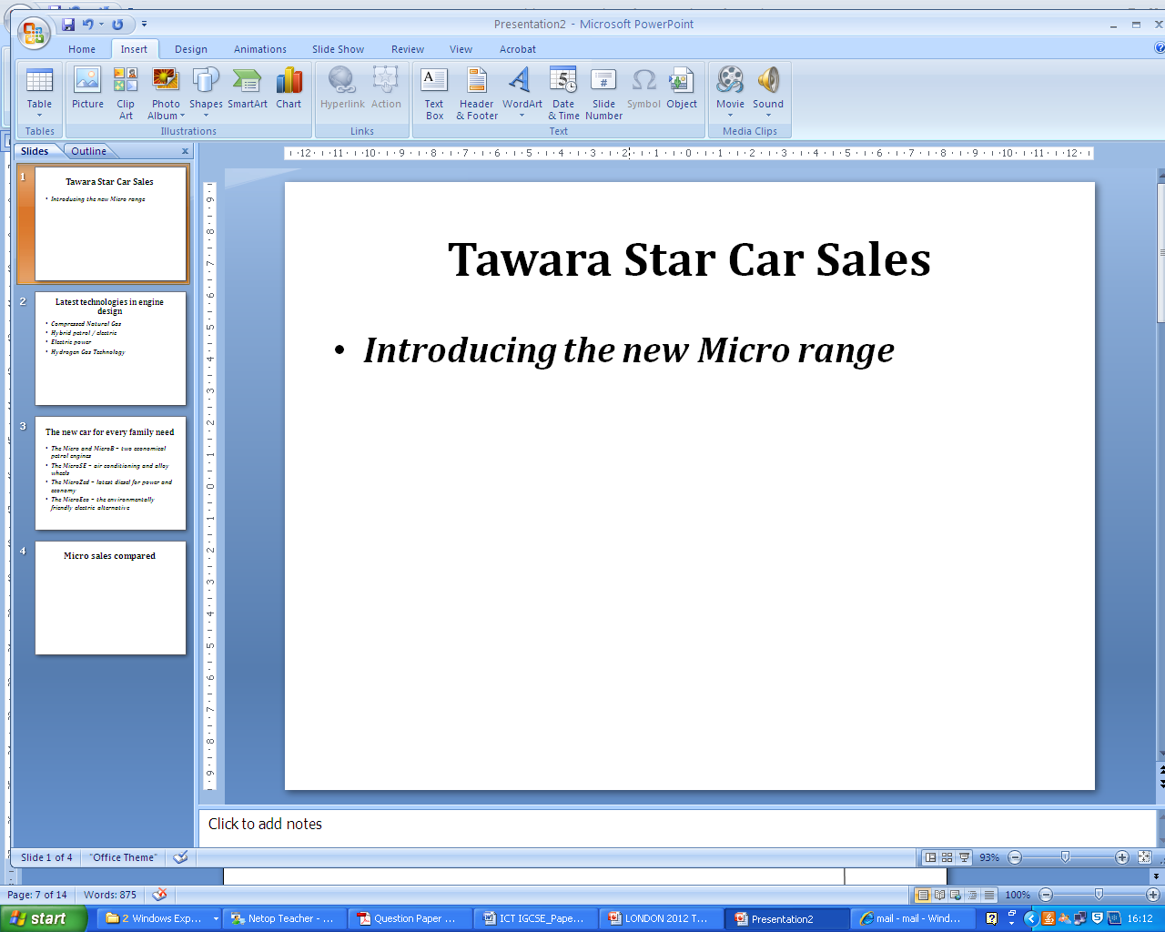
This is where you type the PRESENTATION NOTES
USE ASEARCH CRITERIA to find and display the records wanted in the question paper!
- Applying TRANSITIONS and showing in the screen shots
Select the transition and annotate in the screen shot like shown above.
Can you do it?

- Setting bullet point animation and showing as a screen shot

Select the BULLETED LIST and CUSTOM ANIMATION.

Custom Animation window will open on the right.

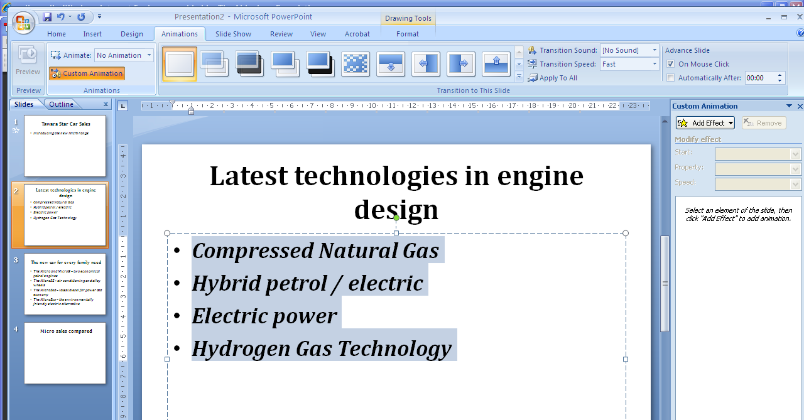

Add the required animation as specified in the question paper.

Can you do it?
Then put the screen shot below in your evidence document with annotations.

- Formatting BACKGROUND

- Printing slides as HANDOUTS

Can you do it?

- Print a slide showing PRESENTER NOTES

Select Notes Pages

